Hard links
Now we do similar actions but with hard links. We have another file in source directory. Whe this command will be executed
ln ../source/file2 hardlink
Let's check
ls -al
Well... This time it looks completely different!
ls -il ../source/file2
ls -il
Both files have the same inode. Let's confirm a few things now.
file hardlink
Will return
hardlink: ASCII text
stat hardlink
Shows
File: hardlink
Size: 7 Blocks: 8 IO Block: 4096 regular file
Device: fc01h/64513d Inode: 775734 Links: 2
Access: (0644/-rw-r--r--) Uid: ( 0/ root) Gid: ( 0/ root)
Access: 2022-05-15 16:51:49.016027786 +0000
Modify: 2022-05-15 16:28:10.878600571 +0000
Change: 2022-05-15 16:28:21.242839463 +0000
Birth: -
Did you noticed 2 as number of links? Last thing, we can check the original file.
stat ../source/file2
File: ../source/file2
Size: 7 Blocks: 8 IO Block: 4096 regular file
Device: fc01h/64513d Inode: 775734 Links: 2
Access: (0644/-rw-r--r--) Uid: ( 0/ root) Gid: ( 0/ root)
Access: 2022-05-15 16:51:49.016027786 +0000
Modify: 2022-05-15 16:28:10.878600571 +0000
Change: 2022-05-15 16:28:21.242839463 +0000
Birth: -

Change content
now we add something to both.
echo 'this is added to original file' >> ../source/file2
echo 'this is added to hard link' >> hardlink
cat hardlink
cat ../source/file2
It works pretty the same like for soft links.

Delete original
Do you remember what happened when we deleted source of soft link? Let's do it for our hardlink now.
rm ../source/file2
And what we have?
ls -al
file hardlink
stat hardlink
cat hardlink
Well, works like nothing was deleted.
Ok, we should bring back original file.
touch ../source/file2 && echo 'hello!'> ../source/file2
Ok, now the check.
ls -il ../source/file2
ls -il hardlink
Hm... different inodes... Do you know what we will find in files?
Answer
As you can expect - two inodes mean that we have two different files. Thesa are not link anymore.

cat ../source/file2
cat hardlink
stat ../source/file2
stat hardlink

Theory again
Ok, here is what happened. Let's think about inode as an element of communication between filesystem and physical storage. Take a look on the picture below. This is how soft link looks
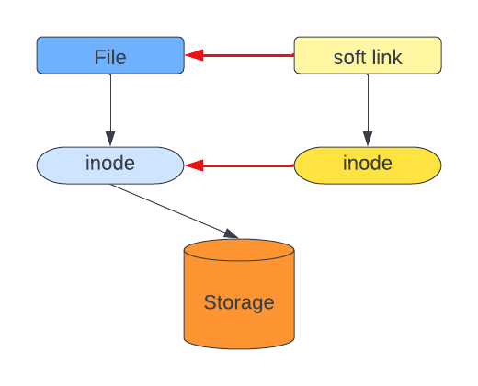
We see that link on the file level is related to the original file. Both files have their own inodes and we can say (it is simplification) that inode of link is a shortcut to inode of original file. Only one inode points to the object on storage - original one.
When we remove the original file:
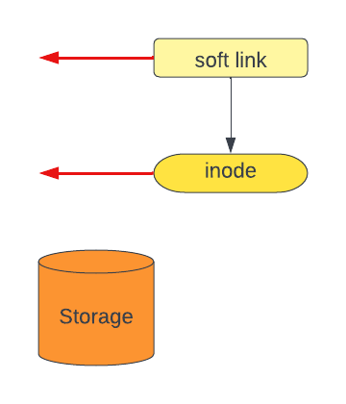
Neither link itself or inode has understanding how to get to the storage. The file is 'lost'.
Ok, how it looks for hard links?
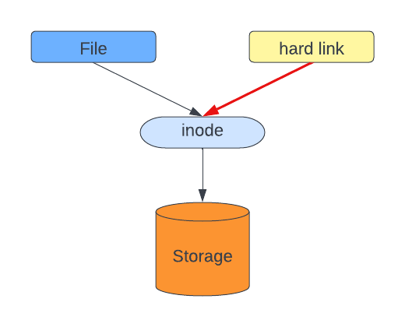
Both files - original and link, point to the same inode. And this inode points to the object on storage. Now, when we remove the original file...
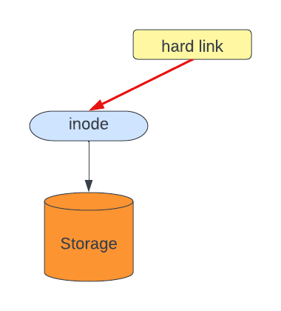
We remove just the file. Inode stays s long as anything is related to it.

